Term: Fall 2018

Assignment 2

# Relational Schema

Please use ERD Plus to create the relational schema for the following ERD diagram.

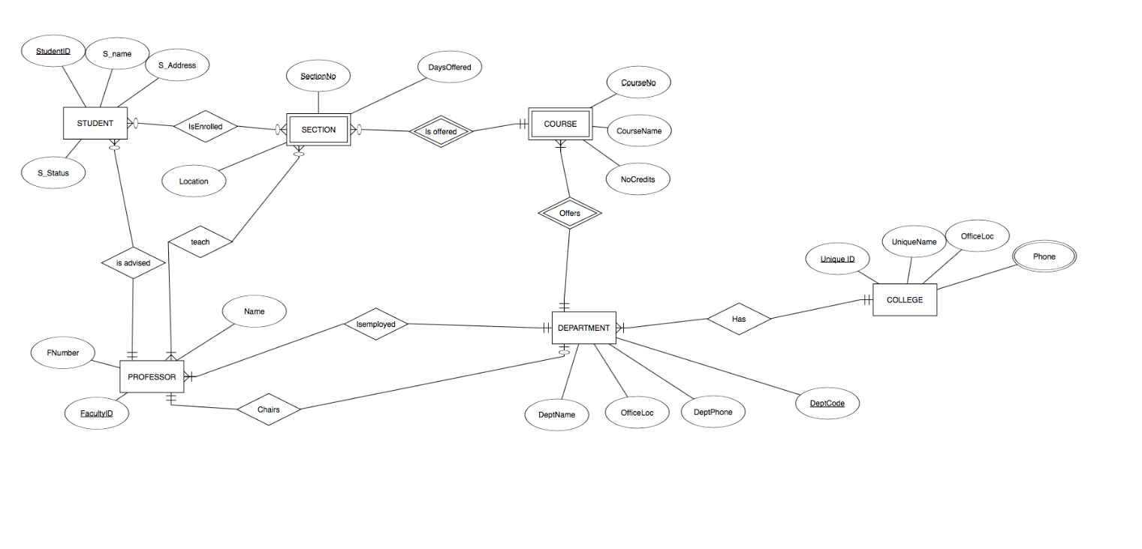

# Turning in the Assignment

Export your diagram from ERD Plus by selecting “*Export Image* (**do not** select “*Export Diagram File*”):

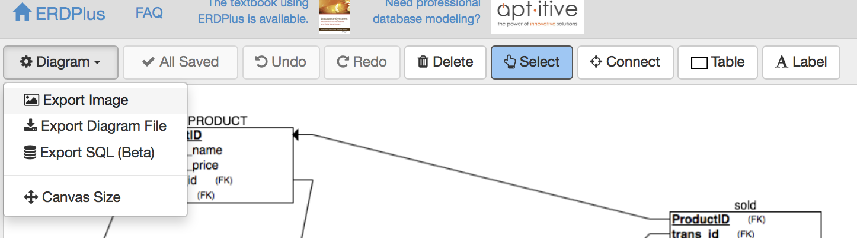

Click save image, and place the file somewhere on your computer where you can find it.

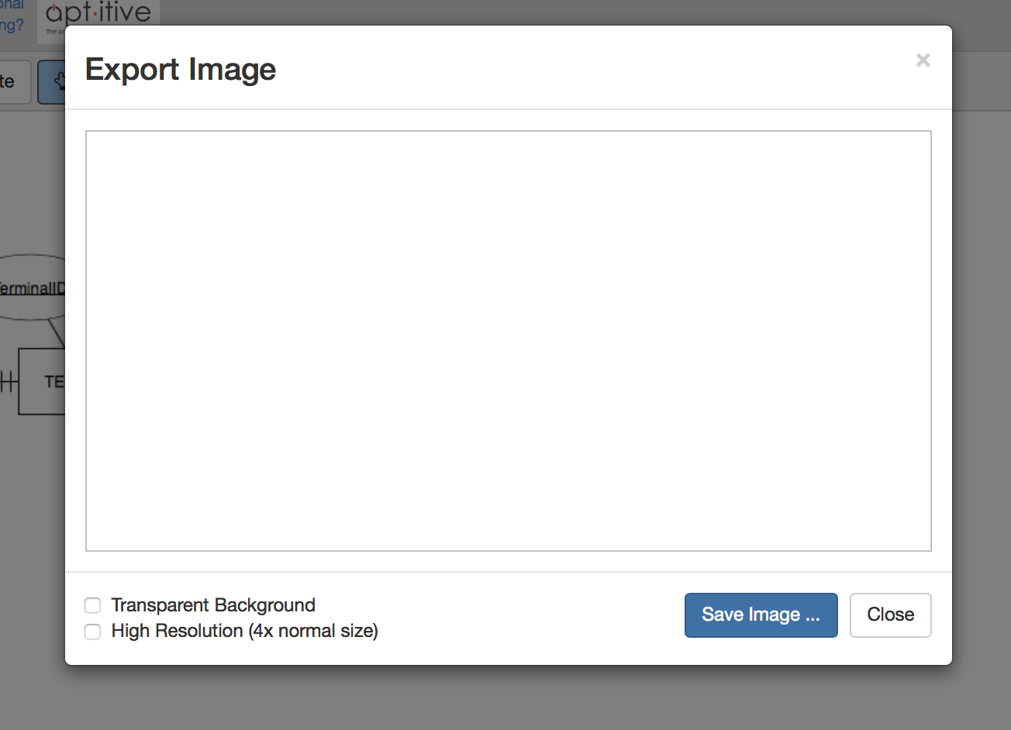

Rename your file with the following format: YourLastNameYourFirstName (leave the png extension). Upload this file to Blackboard, under Assignment 2.